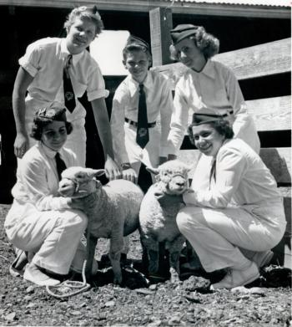
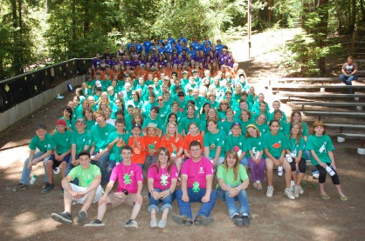
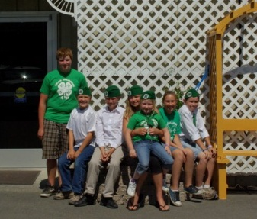

Tell us your story! This year, California 4-H is 100 years old. Tell us in your own words how 4-H has improved your life or community. Send us pictures too!
Need help getting started with your story? Do you have a family member that you'd like to interview and tell their story? Check out the interview form and get started today! Thank you!!!!

My Name: ___________________________________________
Give us your First and Last Name
My Email: ___________________________________________
Give us your email address
My Address: __________________________________________
Give us your mailing address (Street, City, and Zip Code)
My Story: Give us your story in your own words – attached on a separate page

My Pictures
Send us your pictures. Please provide a little information about each photo. We intend to use your photo in our celebration slideshow.
- About what year was it, and where was it taken?
- How old were you and what 4-H club were you a member of?
- What were you doing in the photo?
- How did you feel when the picture was taken? (Tell why)
- Did this moment have a lasting impact on you? (Tell why)

University of California Release Agreement should accompany this form

Please return to: 4-H Centennial Committee c/o UCCE 890 N. Bush Ukiah CA 95482

