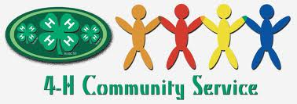
Centennial Service to Community
Ideas for Local and Mendocino County 2013

1. Give out 100 small American flags at a Memorial Day or July 4th parade. Place a tag or sticker saying the flags were “given by ________ 4H Club in honor of country and the 100th anniversary of California 4H.”

2. 100 card challenge – make cards for people in nursing homes, hospitals, meals on wheels, military.

3. Club members read to 100 children or 100 hours in a library program.

4. Collect 100 bags or 100 cubic yards of trash in a community clean up.

5. Plant wildflowers in a public right of way.

6. Volunteer at a food bank/ food pantry on a regular basis.

7. Share your testimony before city, county boards, and councils to address problems facing youth.

8. Interview older 4H alumni to preserve their stories in a video you create

9. Collect and donate 100 stuffed animals to police station or other agency.

10. Collect 100 pairs of gloves, socks, or hat and donate to homeless shelters.

11. Volunteer to lead the Pledge to the Flag at town meetings, city council meetings, or any similar public meeting.

12. Donate 100 hours of service at a local agency.

13. Do face painting for free at a local event. Paint 4H clovers on everyone

14. Decorate trash barrels at the county fair with centennial logo

